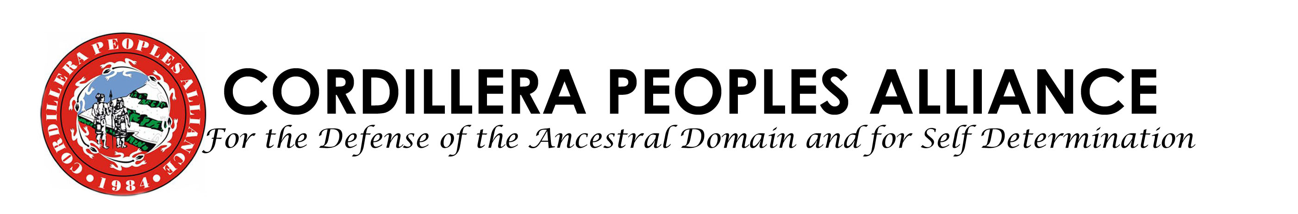

FOR IMMEDIATE RELEASE

October 11, 2009

Cordillera Still in state of calamity;
Relief, Rescue and Retrieval Missions Very Needed

BAGUIO CITY—Various media reports state that the death toll for Cordillera Region has now amounted to about 247 documented cases, around 190 deaths in Benguet and Baguio with 54 bodies retrieved. 1 death has been initially reported from Abra province. The data for those missing has not yet been reported. The deaths, destruction of properties and livelihood sources are a result of the massive landslides all over the region, a total of 18, and the strong rains which flooded parts of the City. Baguio City has over 400 individuals evacuated into barangay halls, schools, gyms and daycare centers. Main highways Marcos, Halsema and Kennon Road remain closed.

The Serve the People Brigade-Cordillera Disaster Response Network yesterday extended relief goods to 160 families in Pinsao and Fairview both in Baguio City, and helped given relief goods, volunteers helped in clearing operations in Ambiong, La Trinidad municipality, and Irisan and Upper P. Burgos in Baguio. Two houses were completely wrecked in Irisan. Residents in Bakakeng Central, BAguio, reported thant a family of 9 were buried in the landslide, including a pregnant mother. The neighboring house reported 4 deaths due to the landslide.

As of today, In Puguis, La Trinidad, 85 bodies have been recovered due to landslides; those missing is still undetermined. During the Brigade’s ocular inspection in Tublay, it was noted that relief and rescue missions, medical attention are needed in the mined out area of Sto.Niño. 50 families were evacuated into the Paoad Elementary School, all from Sto. Niño.

Cordillera Peoples Alliance inter-municipal chapter MAQUITACDG reports that 26 bodies have been recovered in Guinaoang Mankayan, and retrieval operations are still ongoing. The road from Abatan, Buguias to Mankayan remains impassable.

In the landslide in Tadian, Mountain Province, 50 bodies have already been recovered, but many are still missing.

CPA’s affiliate in Apayao province has finally gotten through the telecommunications problem and reported that a total of 2, 449 families have been affected in Conner or 11, 807 individuals while a total of 1,898 hectares of crops were destroyed.

The Serve the People Brigade will hold relief and rescue operations in Itogon and Mankayan in the coming week. Please visit us at No. 55 Ferguson Road, Brgy. A. Bonifacio, Baguio City and look for Mr. Santos Mero, Serve the People Brigade Coordinator and CPA Deputy Secretary General (09152054262) to donate and volunteer. You may also call or text the Hotline at mobile number 09209286370 or Telephone Number 63- 074-304-4239, Fax number is 63-074-443-7159. You can also reach us through email at cpa@cpaphils.org for queries. #

SERVE THE PEOPLE BRIGADE -CORDILLERA DISASTER RESPONSE NETWORK
Cordillera Peoples Alliance
Center for Development Programs in the Cordillera

